1. **Introduction**

**What is GIS?**

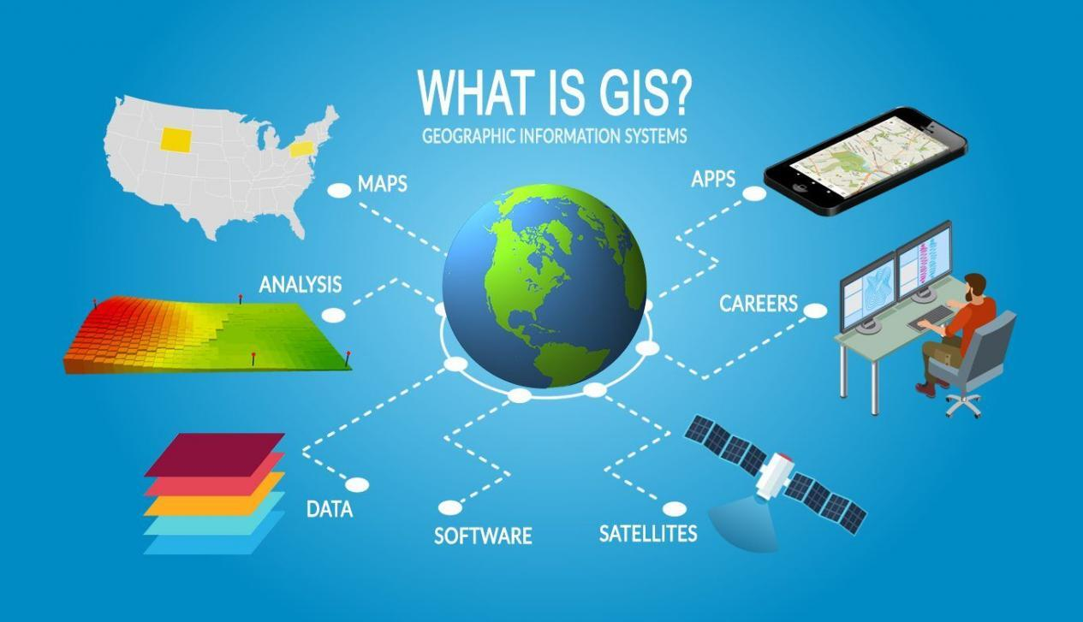

**What is GIS?**

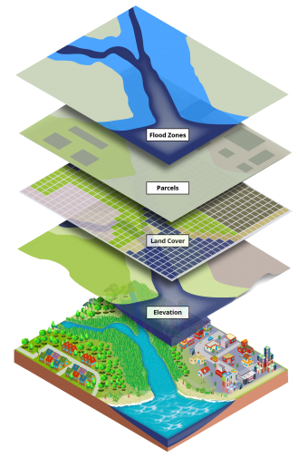GIS stands for **Geographic Information Systems** and is a computer-based tool that examines spatial relationships, patterns, and trends in geography. Geographic Information Systems (GIS) store, analyze, and visualize data for geographic positions on Earth’s surface.

GIS mapping produces visualizations of geospatial information. The 4 main ideas of Geographic Information Systems (GIS) are:

1. Create geographic data.
2. Manage it in a database.
3. Analyze and find patterns.
4. Display it on a map.

Because viewing and analyzing data on maps impacts our understanding of data, we can make better decisions using GIS.

It helps us understand **what** is **where**. The analysis becomes simple. Answers become clear. Otherwise we don’t fully understand the data until we see how it relates to other things in a geographic context.

**What is GIS Mapping?**

It was used back in 1854 (without computers of course!) in the City of London. Fundamentally, we still use this type of spatial analysis today but in a more sophisticated way (see The Remarkable History of GIS, lecture -2).

In a nutshell:

Data without spatial reference doesn’t provide geographic context. And without geographic context, we can’t fully understand the world that we live in today.

That’s why we need Geographic Information Systems (GIS) and how come it’s making a substantial impact in our daily lives.

**What are the Use Cases of GIS?**

Every day, GIS powers millions of decisions around the world. It makes a big impact on our lives and you might not even realize it. For example, we use GIS for:

1. Pinpointing new store locations
2. Reporting power outages
3. Analyzing crime patterns
4. Routing in car navigation
5. Forecasting and predicting weather

**How to Visualize Geography with Maps**

It’s REALLY hard to visualize [**latitude and longitude coordinates**](https://gisgeography.com/latitude-longitude-coordinates/) from a spreadsheet.

|  |  |  |
| --- | --- | --- |
| **City** | **Latitude** | **Longitude** |
| Seattle | 47.5° | -122.3° |
| New York | 40.7 | -73.9° |
| Miami | 25.8° | -80.2° |
| Los Angeles | 33.9° | -118.2° |

But when you add these positions on a map, suddenly spreadsheets come to life.

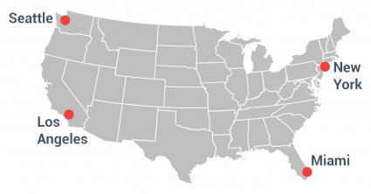

That’s because maps make geographic information easier to understand.

When we have geographic context, we don’t only see where they are on a map. But we can:

1. Calculate how far points are from each other
2. Check if points are clustered for patterns and trends
3. Find the optimal route between cities

**Components of Geographic Information Systems**

The 3 main components of Geographic Information Systems are:

**1. Data**

GIS stores location data as [thematic layers](https://gisgeography.com/what-is-geodata-geospatial-data/). Each data set has an attribute table that stores information about the feature. The two main types of GIS data are [raster and vector](https://gisgeography.com/spatial-data-types-vector-raster/):

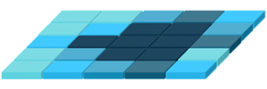**Raster**

Raster data look like grids because they store data in rows and columns. They can be discrete or continuous. For example, we often represent land cover, temperature data, and imagery as raster data.

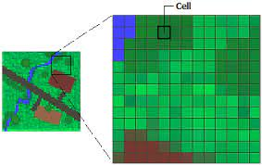A common use of raster data in a GIS is as a background display for other feature layers. For example, orthophotographs displayed underneath other layers provide the map user with confidence that map layers are spatially aligned and represent real objects, as well as additional information.

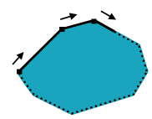

**Vector**

Vectors are points, lines, and polygons with vertices. For example, fire hydrants, contours, and administrative boundaries are often vectors.

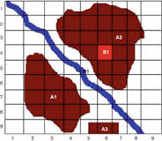Vector data in a GIS is represented as a collection of simple geometric objects such as points, lines, polygons, arcs, circles, etc. For example, a city may be represented by a point, a road may be represented by a collection of lines, and a state may be represented as a polygon.

# Vector vs Raster: What’s the Difference between GIS Spatial Data Types?

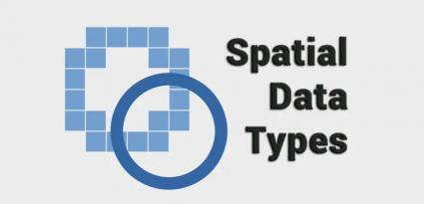

**Spatial data** observations focus on locations.

Every house, every tree, and every city has its own unique [latitude and longitude coordinates](https://gisgeography.com/latitude-longitude-coordinates/).

The two primary types of spatial data are **vector and raster data**in a GIS.

When should we use raster and when should we use vector features? Find out more about the spatial data models commonly used.

### Vectors models are points, lines, and polygons

Vector data is **not** made up of a grid of pixels. Instead, vector graphics are comprised of **vertices and paths**.

The three basic symbol types for vector data are points, lines, and polygons (areas).

Because cartographers use these symbols to represent real-world features in maps, they often have to decide based on the [level of detail](https://gisgeography.com/map-elements-how-to-guide-map-making/) on the map.

#### Points are XY coordinates

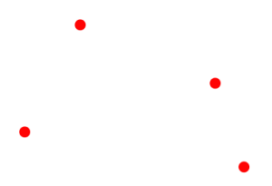

**Vector points** are simply XY coordinates. Generally, they are latitude and longitude with a [spatial reference frame](https://gisgeography.com/horizontal-datum/).

When features are too small to be represented as polygons, points are used.

For example, we can’t see city boundary lines on a global scale. In this case, maps often use points to display cities.

#### Lines connect vertices

Vector lines connect each vertex with paths. Basically, you’re connecting the dots in a set order and it becomes a **vector line** with each dot representing a vertex.

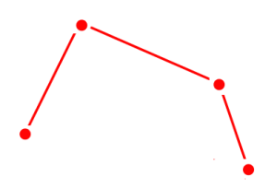

Lines usually represent features that are linear in nature. For example, maps show rivers, roads, and pipelines as vector lines. Often, busier highways have thicker lines than abandoned roads.

On the other hand, networks are line data sets but they are often considered to be different. This is because linear networks are [topologically connected elements](https://gisgeography.com/topology-rules-arcgis/). They consist of junctions and turns with connectivity.

#### Polygons connect vertices and close the path

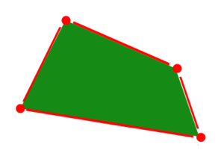

When we join a set of vertices in a particular order and close it, this is now a **vector polygon** feature. When you create a polygon, the first and last coordinate pairs are the same.

Cartographers use polygons to show boundaries and they all have an area. For example, a building footprint has square footage, and agricultural fields have acreage.

### Raster Types: Discrete vs Continuous

**Raster data** is made up of pixels (also referred to as grid cells). They are usually regularly spaced and square but they don’t have to be. Raster’s often look pixelated because each pixel has its own value or class.

**For example:**

Each pixel value in a [satellite image](https://gisgeography.com/free-satellite-imagery-data-list/) has a red, green, and blue value. Alternatively, each value in an elevation map represents a specific height. It could represent anything from rainfall to [land cover](https://gisgeography.com/free-global-land-cover-land-use-data/).

Raster models are useful for storing data that varies continuously. For example, [elevation surfaces](https://gisgeography.com/free-global-dem-data-sources/), temperature, and lead contamination.

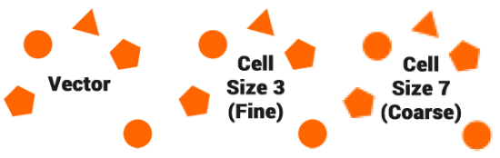

Raster data models consist of 2 categories – discrete and continuous.

#### Discrete Rasters have distinct values

1. **Discrete rasters** have distinct themes or categories. For example, one grid cell represents a land cover class or a soil type.

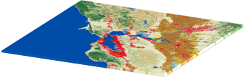

1. In a discrete raster [land cover/use map](https://gisgeography.com/free-global-land-cover-land-use-data/), you can distinguish each thematic class. Each class can be discretely defined where it begins and ends.
2. In other words, each land cover cell is definable and it fills the entire area of the cell.
3. Discrete data usually consists of integers to represent classes. For example, the value 1 might represent urban areas, the value 2 represents forest, and so on.

#### Continuous Rasters have a gradual change

**Continuous rasters** (non-discrete) are grid cells with gradually changing data such as elevation, temperature, or an aerial photograph.

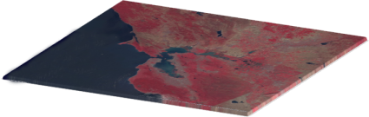

A continuous raster surface can be derived from a **fixed registration point**. For example, digital elevation models use sea level as a registration point.

Each cell represents a value above or below sea level. As another example, [**aspect cell values**](https://gisgeography.com/slope-aspect-microclimate-south-facing/) have fixed directions such as north, east, south, or west.

Phenomena can gradually vary along a continuous raster from a **specific source**. A raster depicting an oil spill can show how the fluid moves from high concentration to low concentration. At the source of the oil spill, concentration is higher and diffuses outwards with diminishing values as a function of distance.

### Difference Between Raster and Vector Data - Comparison Summary

### Vector data advantages and disadvantages

#### Advantages of using vector data

1. Because vector data have vertices and paths, this means that the graphical output is generally more aesthetically pleasing.
2. Furthermore, it gives higher geographic accuracy because data isn’t dependent on grid size.
3. Topology rules can help data integrity with vector data models. Not only that, network analysis and proximity operations use vector data structures.

#### Disadvantages of using vector data

1. Continuous data is poorly stored and displayed as vectors.
2. Displaying continuous data as a vector, it would require substantial generalization.
3. Topology is useful for vector data, it is often processing intensive. Any feature edits require updates on topology.
4. With a lot of features, vector manipulation algorithms are complex.

#### Advantages of raster data

1. A raster grid format is a data model for satellite data and other [remote sensing](https://gisgeography.com/remote-sensing-earth-observation-guide/) data. For raster positions, it’s simple to understand cell size.
2. [**Map algebra**](https://gisgeography.com/map-algebra-global-zonal-focal-local/) with raster data is usually quick and easy to perform. Overall, quantitative analysis is intuitive with discrete or continuous rasters.

**[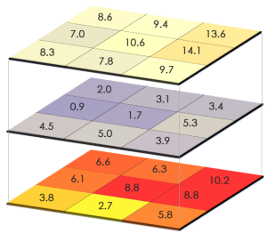](https://gisgeography.com/wp-content/uploads/2015/05/Map-Algebra.png)**

#### Disadvantages of raster data

1. Because cell size contributes to graphic quality, it can have a pixelated look and feel. To illustrate, linear features and paths are difficult to display.
2. We can’t create network datasets or perform [topology rules](https://gisgeography.com/topology-rules-arcgis/) on rasters. Also, we don’t have the flexibility with raster data attribute tables.
3. Raster datasets can become potentially very large because they record values for each cell in an image. As resolution increases, the size of the cell decreases. But this comes at a cost for speed of processing and data storage.

### Vector vs Raster: Spatial Data Types

It’s not always straightforward which spatial data type we should use for our maps.

In the end, it really comes down to how the cartographer conceptualizes the feature on their map (observations/decisions).

* **Do you want to work with pixels or coordinates?** Raster data works with pixels. Vector data consists of coordinates.
* **What is your map scale?** Vectors can scale objects up to the size of a billboard. But we don’t get that type of flexibility with raster data
* **Do you have restrictions on** file size? Raster file size can result in larger in comparison with vector data sets with the same phenomenon and area.

There are some of the features you have to think about during the data design and conceptualization phase.

### Vector data is a geographic data type where data is stored as a collection of points, lines, or polygons along with attribute data. Individual points recorded as coordinate pairs, which represent a physical position in the world, make up vector data at its most basic level.

### Rasters data are digital aerial photographs, imagery from satellites, digital pictures, or even scanned maps. Data stored in a raster format represents real-world phenomena: Thematic data (also known as discrete) represents features such as land-use or soils data.

### Spatial data structures store data objects organized by position and are an important class of data structures used in geographic information systems, computer graphics, robotics, and many other fields. A number of spatial data structures are used for storing point data in two or more dimensions.

**2. Hardware**

Hardware runs GIS software. It could be anything from powerful servers, mobile phones, or a personal [**GIS workstation**](https://gisgeography.com/gis-workstation-computer-components/). The CPU is your workhorse and data processing is the name of the game. Dual monitors, extra storage, and crisp graphic processing cards are must-haves too in GIS.

**3. Software**

[ArcGIS and QGIS](https://gisgeography.com/arcgis-pro-vs-qgis-3/) are the leaders in [GIS software](https://gisgeography.com/free-gis-software/). GIS software specializes in spatial analysis by using math in maps. It blends geography with modern technology to measure, quantify and understand our world.

Finally, GIS consists of:

* **Digital Data** –– the geographical information that you will view and analyse using computer hardware and software.
* **Computer Hardware** –– computers used for storing data, displaying graphics and processing data.
* **Computer Software** –– computer programs that run on the computer hardware and allow you to work with digital data. A software program that forms part of the GIS is called a GIS Application.

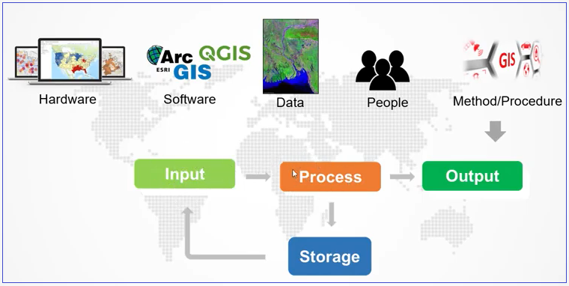

**GIS Drive Decisions with Spatial Analysis**

Never before have we had more pressing issues in need of a geospatial perspective. For example, [**climate change**](https://gisgeography.com/climate-change-effects-maps/), natural disasters, and population are all geographic in nature. These global issues need location-based knowledge that can only come from a GIS.

Most people think GIS is only about “making maps”. But we harness the power of GIS because of the insights of [**spatial analysis**](https://gisgeography.com/spatial-analysis/). We use spatial analysis through math in maps. Spatial analysis is difficult with paper maps so that’s why we need GIS. Here are examples of spatial analysis:

**Buffer**

The [**buffer tool**](https://gisgeography.com/buffer-tool-multiple-ring-geodesic-euclidean-round-square/) generates a polygon around features at a set distance. By creating buffers, you can find the surrounding features that are within buffers.

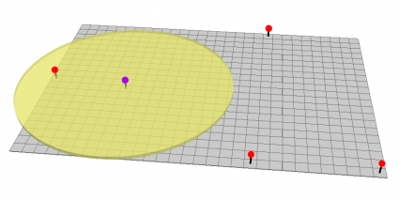

**Hot Spot/old spots**

Hot spots highlight areas that have clusters of points. Whereas cold spots have a small density of points.

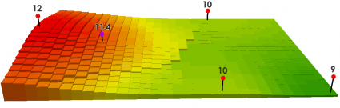

**Discipline/Career in Geomatics/GIS**

From planning a pipeline to navigating ships, spatial problems need spatial thinkers. This is why Geographic Information Systems has expanded into countless disciplines. GIS careers are booming for:

* **CARTOGRAPHERS** create maps. In fact, the origin of [**“cartographer”**](https://gisgeography.com/cartographer-job-salary/) comes from charta which means “tablet or leaf of paper” and graph “to draw”
* **DATABASE MANAGERS** store and extract information from structured sets into [**spatial databases**](https://gisgeography.com/spatial-databases/).
* **PROGRAMMERS** write code and automate redundant GIS processes. For example, [**GIS programming**](https://gisgeography.com/free-gis-programming-tutorials/) languages include Python, SQL, C++, Visual Basic, and JavaScript.
* **REMOTE SENSING SPECIALISTS** use aerial, [**satellite imagery**](https://gisgeography.com/free-satellite-imagery-data-list/), and [**remote sensing software**](https://gisgeography.com/open-source-remote-sensing-software-packages/).
* **SPATIAL ANALYSTS** use **[geoprocessing tools](https://gisgeography.com/geoprocessing-tools/)** to manipulate, extract, locate and analyze geographic data.
* **LAND SURVEYORS** measure the 3-dimensional coordinates on the land.

**GIS Started by Mapping Cholera**

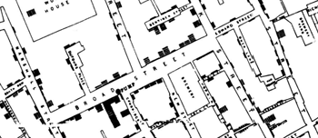

In 1854, cholera hit the city of London, England. No one knew where the disease started. So, British physician John Snow started mapping the outbreak.

It wasn’t just the disease. But he also mapped out roads, property boundaries, and water lines.

When he added these features to a map, something interesting happened. He noticed that cholera cases were only along one water line. This was a breakthrough that connected geography to public health safety. But it wasn’t only the beginning of [**spatial analysis**](https://gisgeography.com/spatial-analysis/). It also marked the start of epidemiology, the study of the spread of disease.

In 1968, a man by the name of Roger Tomlinson started piecing together modern computing with maps. In fact, he first coined the term “GIS” in his paper “[**A Geographic Information System for Regional Planning**](https://pdfs.semanticscholar.org/266c/362ae00c82ccf8a4f9b6467da511aa0bd5e1.pdf)“. At this moment, GIS truly became a computer-based tool for storing map data. In 2014, Roger Tomlinson later passed away and will always be remembered as the “father of GIS”.



*“Great discoveries and improvements invariably involve the cooperation of many minds. I may be given credit for having blaze the trail of GIS. But when I look at the subsequent development, I feel the credit is due to others rather than just myself.”*

— Roger Tomlinson, *The Father of GIS*

**GIS Uses and Applications**

Geographic Information Systems is jam-packed with example use cases. For example, we’ve found over [**1000 GIS uses and applications**](https://gisgeography.com/gis-applications-uses/). Here are some examples below.

1. **ENVIRONMENT:** By far, the heaviest users are for the environment. For example, conservationists use GIS for climate change, groundwater studies, and impact assessments.

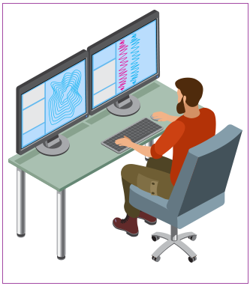

1. **MILITARY AND DEFENSE:** The military is a heavy user of GIS. They use it for location intelligence, logistics management, and [**spy satellites**](https://gisgeography.com/earth-satellite-list/).
2. **AGRICULTURE:** Farmers use it for precision farming, [**soil mapping**](https://gisgeography.com/agriculture-maps-global-farming/), and crop productivity.
3. **FORESTRY:** Foresters manage timber, [**track deforestation**](https://gisgeography.com/global-forest-maps/), and inventory forest stands with GIS.
4. **BUSINESS:** More on the business side of things, GIS is for [**site selection**](https://gisgeography.com/optimal-business-location-allocation/), consumer profiling, and customer prospecting.
5. **REAL ESTATE:** Examples in real estate include market analysis, home valuations, and zoning.
6. **PUBLIC SAFETY:** GIS shows the [**spread of disease**](https://gisgeography.com/real-time-disease-map-healthmap/), disaster response, and public health.

**What Can GIS Do For You?**

Geographic Information Systems better answer questions about location, patterns, and trends. For example:

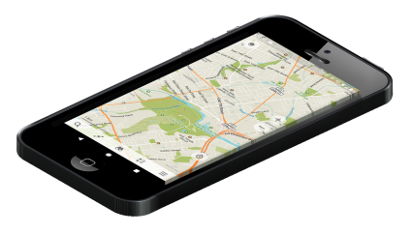

1. **Where are the land features found?** If you need to find the closest gas station, GIS can show you the way. GIS can find optimal locations by connecting traffic volumes, zoning information, and demographics.
2. **What geographical patterns exist?** In conservation, we want to know animal habitats using GPS collars and [**land cover**](https://gisgeography.com/free-global-land-cover-land-use-data/). By knowing animal locations, we can correlate preferred land types with GPS locations. In the end, we have a massive database with all types of species of animals.
3. **What changes have occurred over a given period of time?** Time is the missing element in studying change. For example, we understand change through [**remote sensing of the environment**](https://gisgeography.com/remote-sensing-of-the-environment/). Also, we better predict disasters by finding changes over time.
4. **What are the spatial implications?** If a company wants to build a new project, GIS excels in storing environment data. Most environmental assessments use GIS to understand the impact of projects on the landscape.

**What is Geographic Information Science (GISc)?**

While Geographic Information Systems answers “what” and “where”, Geographic Information Science (GIScience) is concerned with the “how” and its development.

[**Geographic Information Science**](https://gisgeography.com/giscience-geographic-information-science/) provides all the **building blocks** for Geographic Information Systems. It draws from computer science, mathematics, geography, statistics, cartography, and [**geodesy**](https://gisgeography.com/geodesy/).

GIScience incorporates the knowledge from these fields into Geographical Information Systems.

* Geographic Information Systems connects **what**with the **where**.
* Geographic Information Science discovers **how**.

**[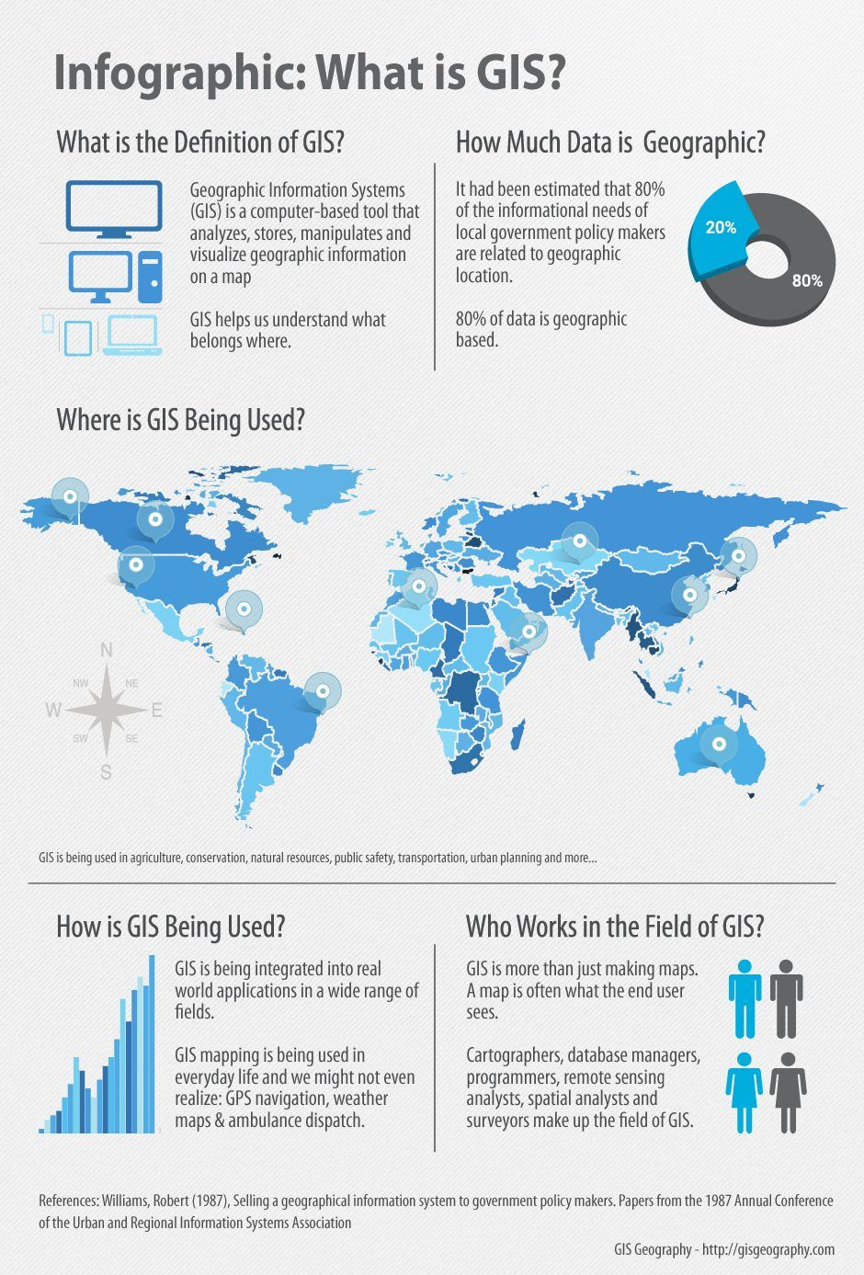](https://gisgeography.com/what-gis-geographic-information-systems/geographic-information-systems-gis-infographic/)**

**Questions**

1. What is GIS? State four main ideas of Geographic Information Systems (GIS).
2. Components of Geographic Information Systems
3. When should we use raster and when should we use vector features? Find out more about the spatial data models commonly used.
4. Explain the difference between vector data and raster data.
5. Mention some applications and Career of GIS